EXPERIMENT 1
EXPERIMENT 1(a) - Cisco Packet Tracer Overview
Aim
To understand the Cisco Packet Tracer interface and basic networking devices.

Theory
Cisco Packet Tracer is a network simulation tool used to design, configure, and troubleshoot networks virtually.
It allows us to:
- Create network topologies
- Configure routers, switches, PCs
- Test connectivity using ping
- Learn networking practically without real hardware

Main Components of Packet Tracer
Component | Purpose
End Devices | PC, Laptop, Printer
Network Devices | Router, Switch, Hub
Connections | Copper cable, Fiber cable
Simulation Mode | Observe packet flow

Procedure
- Open Cisco Packet Tracer.
- Observe the interface:
  - Device panel (bottom left)
  - Workspace (center)
  - Connection tools (bottom)
- Drag the following devices:
  - 1 Router
  - 1 Switch
  - 2 PCs
- Connect devices using Copper Straight Through cable.

Result
Successfully explored Cisco Packet Tracer interface.

Conclusion
We learned the basic interface and components of Packet Tracer.
EXPERIMENT 1
EXPERIMENT 1(b) - Peer-to-Peer Network
Aim
To create a Peer-to-Peer network and test connectivity.
Theory
A Peer-to-Peer (P2P) network is a network where computers connect directly without a central server.
Features:
- Simple setup
- Low cost
- Suitable for small networks

Topology Diagram (along with IPv4 address)
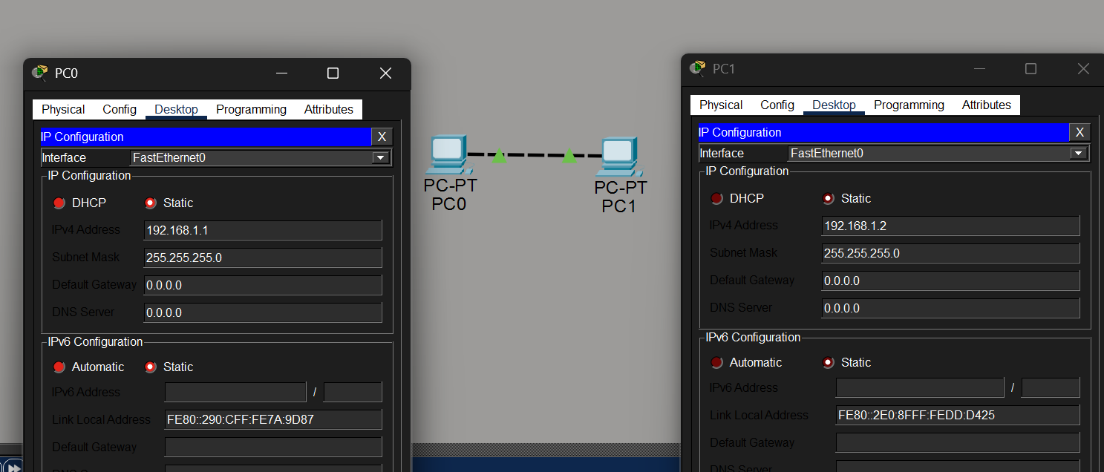
Procedure
Step 1 — Add Devices
Drag:
- PC0
- PC1
Step 2 — Connect PCs
Click ⚡ Connections → choose Copper Cross-Over cable
Connect:
PC0 FastEthernet → PC1 FastEthernet
Step 3 — Assign IP Address
Click PC0 → Desktop → IP Configuration
Enter:
IP Address: 192.168.1.1
Subnet Mask: 255.255.255.0
Click PC1 → Desktop → IP Configuration
Enter:
IP Address: 192.168.1.2
Subnet Mask: 255.255.255.0
Step 4 — Test Connectivity (Ping)
On PC0:
Desktop → Command Prompt → type:
ping 192.168.1.2

Result / Output
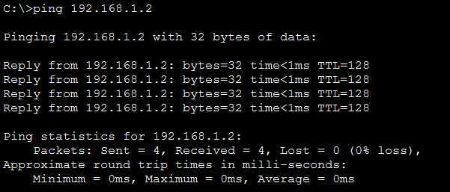
Ping successful between PC0 and PC1.
Conclusion
Peer-to-Peer network successfully created and tested.

EXPERIMENT 2
Network Topologies – (Star, Ring, Mesh, Tree) Topology
2(a) STAR TOPOLOGY
Aim
To implement Star topology using a switch.

Theory
Star topology connects all devices to a central switch/hub.
If one cable fails, rest of network works.

Devices Required
- 1 Switch (2960) & 4 PCs & Copper Straight Through cables

Topology Diagram
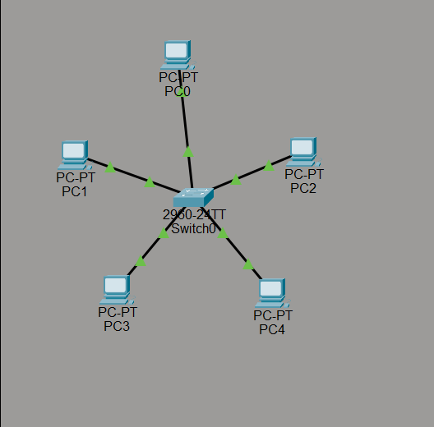

Procedure (Packet Tracer)
- Drag 1 Switch & Drag 4 PCs & Connect all PCs to switch using Straight Through cable.
- Assign IPs:
PC | IP
PC0 | 192.168.1.1
PC1 | 192.168.1.2
PC2 | 192.168.1.3
PC3 | 192.168.1.4
Subnet mask: 255.255.255.0
- Ping from PC0 → PC3
Conclusion
Star topology implemented successfully
EXPERIMENT 2
Network Topologies – (Star, Ring, Mesh, Tree) Topology
2(b) RING TOPOLOGY
Aim
To implement ring topology using a switch.
Theory
Each device connects to exactly two devices forming a ring.
Devices Required
- 4 PCs & Cross-over cables.

Topology Diagram
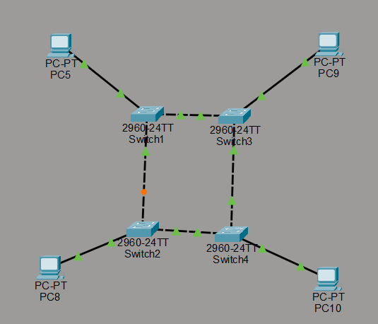

Procedure
- Connect:
PC0 ↔ PC1 ↔ PC2 ↔ PC3 ↔ PC0
- Assign IPs:
192.168.2.1 – 192.168.2.4
- Ping from PC0 → PC3

Conclusion
Ring topology implemented.
EXPERIMENT 2
Network Topologies – (Star, Ring, Mesh, Tree) Topology
2(c) MESH TOPOLOGY
Aim
To implement mesh topology using a switch.
Theory
Every device connects to every other device. Highly reliable but expensive
Devices Required
- 3 PCs & Cross-over cables.

Topology Diagram
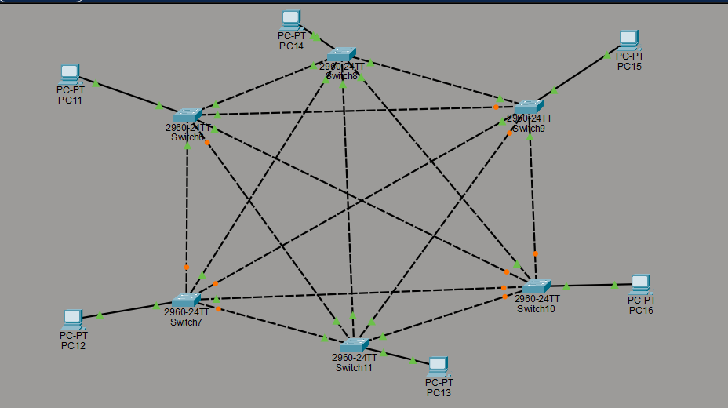
Procedure
Connect each PC to every PC (cross-over cables).
IPs: 192.168.3.1 – 192.168.3.3
Ping all devices from PC0 → PC3

Conclusion
Mesh topology verified.
EXPERIMENT 2
Network Topologies – (Star, Ring, Mesh, Tree) Topology
2(d) TREE TOPOLOGY
Aim
To implement tree topology using a switches.

Theory
Combination of star + bus.
Devices Required
- 4 PCs & 2 switches

Topology Diagram
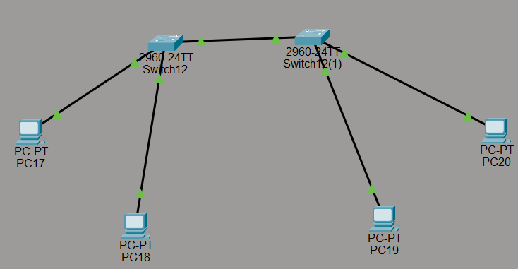
Procedure
Switch0 → Switch1 → PCs
IPs:
192.168.4.1 – 192.168.4.4
Ping all.

Conclusion
Tree topology verified.
EXPERIMENT 3

LAN USING HUB & SWITCH

Theory
Hub broadcasts data to all devices.
Switch sends data only to destination device.

Devices
1 Hub/switch + 4 PCs

Procedure
- Connect PCs to hub/switch.
- Assign IPs:
192.168.5.1 – .4
- Ping all.
3(a) LAN USING HUB
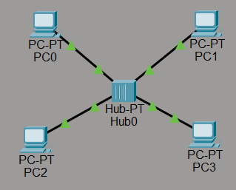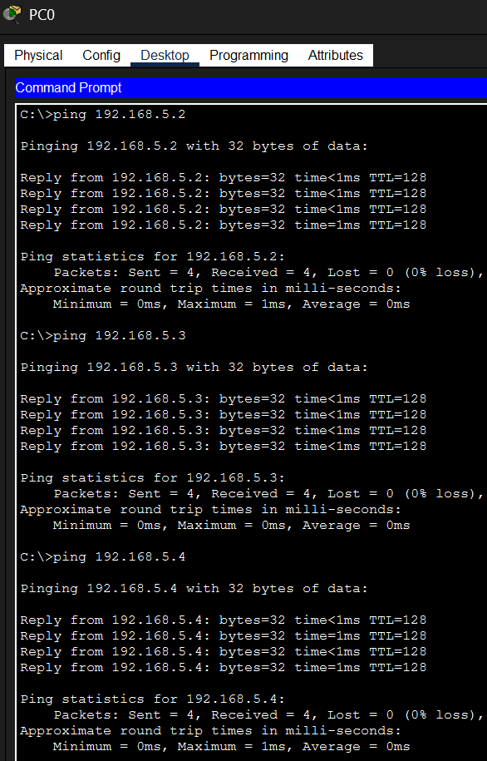

Observation
Hub sends traffic to all devices.

3(b) LAN USING SWITCH
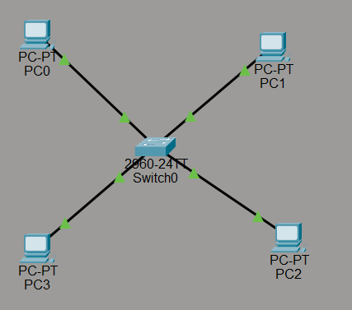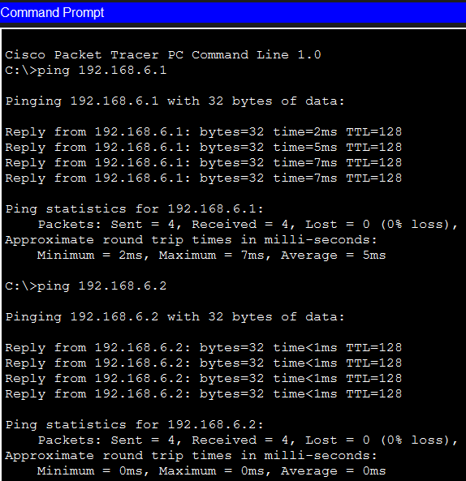
Observation
Switch sends data only to the intended device

EXPERIMENT 4

PING & TRACERT

Aim
To test network connectivity.
Theory
Ping: Checks connectivity using ICMP.
Tracert: Shows path packets travel.
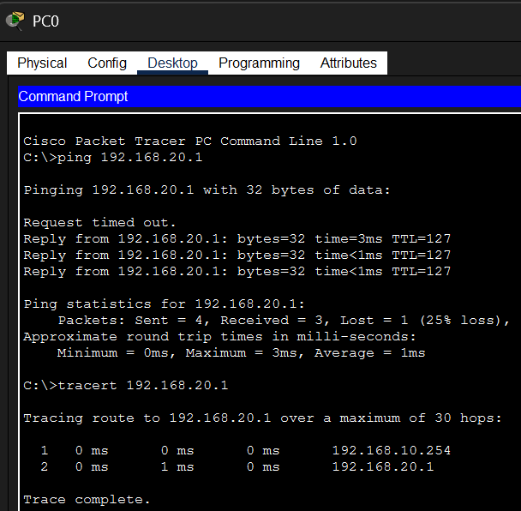
Procedure
Create:
PC → Switch → Router → PC
Assign IPs:
PC0 → 192.168.10.1
Router → 192.168.10.254
PC1 → 192.168.20.1
Use router to connect networks.
Run: ping 192.168.20.1
tracert 192.168.20.1
Topology Diagram
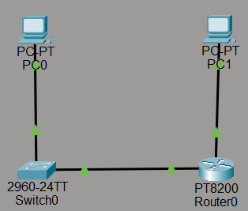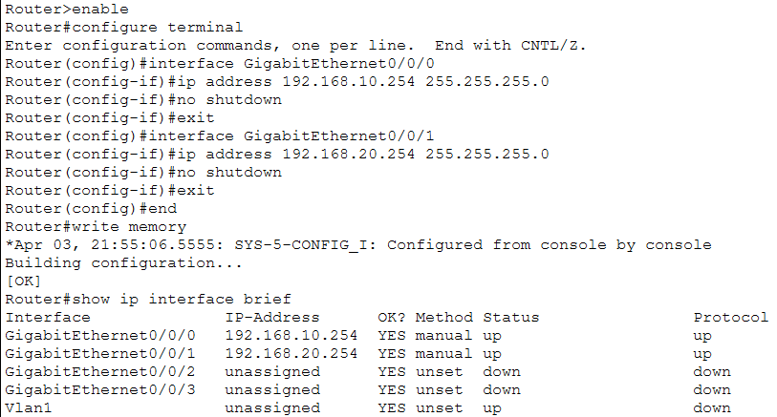

EXPERIMENT 5
CAMPUS AREA NETWORK (CAN)
5(a) Network Design (Description)
The university has:
- 3 Computer Labs (First, Second, Third Floor) & 1 Faculty Room & 1 Server Room
Requirements:
- 1 Router
- 1 Core Switch (Server Room)
- 4 Access Switches (for labs & faculty room)
- 20 PCs (Labs)
- 6 PCs (Faculty Room)
- 1 server room
Diagram:
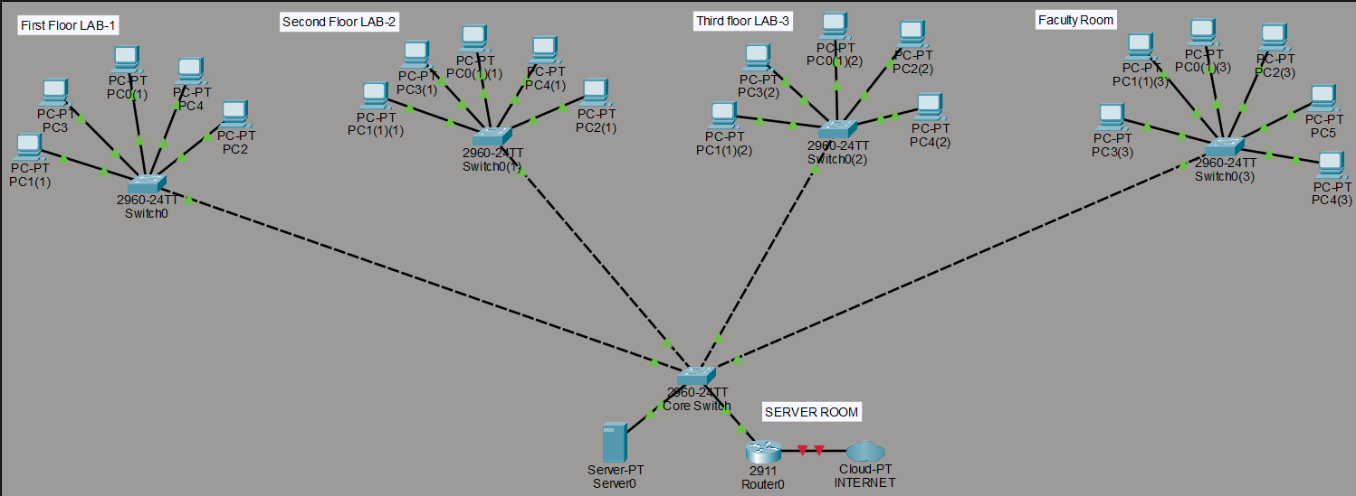

5(b) Static IP Assignment: Assign IPs manually to all PCs & Ping between departments.
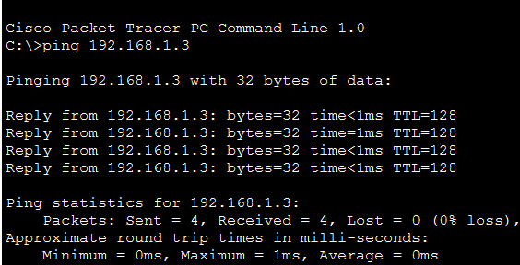
Result:
- Campus Area Network topology was successfully designed.
- Static IP addresses were assigned to all devices based on floor-wise subnetting.

EXPERIMENT 6
IP & SUBNETTING
Aim
To divide network using subnetting.
Given:
Network: 192.168.1.0
Divide into 4 subnets.
Subnets: Configure router interfaces for each subnet.
Dept | Network
Admin | 192.168.1.0/26
HR | 192.168.1.64/26
Sales | 192.168.1.128/26
IT | 192.168.1.192/26
Ping across departments.
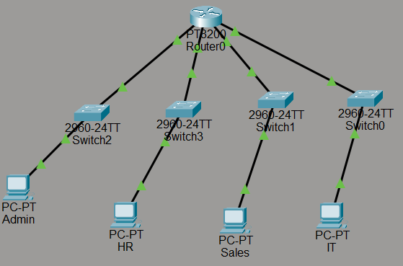

EXPERIMENT 7
WIRELESS NETWORK
Aim
Configure home wireless network.
Devices
- Wireless Router
- Laptop
- Smartphone
- PC

Steps
- Add Wireless Router.
- Set SSID: HomeWiFi
- Set Password: 12345678
- Connect devices using wireless.
Diagram:
